***Assignment 3***



***Operating Systems***

***Name: Ateeq Ur Rehman***

***Roll No: 221475 BSCS-5-C***

***Submitted To: Mam Warda Aslam***

***Department of Computer Science***

Table of Contents

**Comparative Analysis of AndroidOS and MacOS** 3

**1. Process Management** 3

**2. Memory Management** 4

**3. File System** 5

**4. Security** 6

**5. Scheduling** 7

**6. Analogy** 7

**7. Insights and Observations** 8

**8. Comparative Analysis of AndroidOS and MacOS: Key Differences** 9

**References** 10

# **Comparative Analysis of AndroidOS and MacOS**

**Overview:** AndroidOS and MacOS are two distinct operating systems, each optimized for different use cases and hardware ecosystems. AndroidOS, developed by Google, dominates the mobile platform with its open-source flexibility, while MacOS, by Apple, is a UNIX-based system known for its seamless integration within Apple's ecosystem and emphasis on security and user experience [1].

**Purpose:** This report aims to compare AndroidOS and MacOS across several OS concepts to provide insights for users, developers, and enthusiasts.

## **1. Process Management**

**AndroidOS:**

* Employs a process hierarchy based on user interaction, prioritizing foreground processes, followed by visible, service, background, and empty processes [2].
* Uses Linux-based mechanisms for inter-process communication (IPC), such as Intents for high-level messaging, Binder for direct communication, and AIDL for remote method invocation [2].
* Relies on Java Virtual Machine threads with dynamic priority adjustments, allowing responsiveness to user actions while efficiently managing background tasks [2].

**MacOS:**

* Implements preemptive multitasking and process isolation to ensure stability and performance [3].
* Uses Mach and BSD components, with Mach handling low-level kernel tasks like IPC and BSD providing robust file and process management [3].
* Supports advanced multitasking with priority-based threading, ensuring critical system processes have sufficient resources [3].

The chart below illustrates the hierarchical prioritization of processes in AndroidOS, comparing the relative importance of each process type.

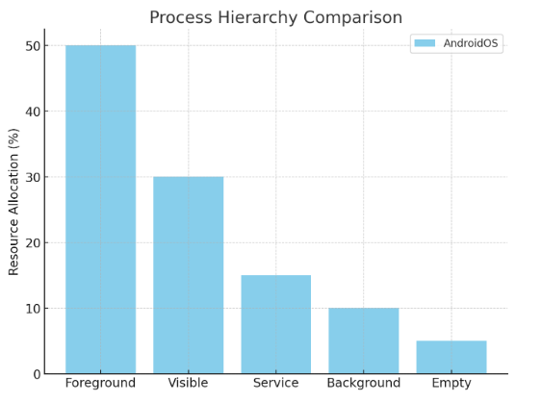

## **2. Memory Management**

**AndroidOS:**

* Utilizes paging and memory mapping to manage app memory efficiently [2].
* Employs garbage collection through Android Runtime (ART) to reclaim unused memory, reducing memory leaks [2].
* Shares memory across processes via the Zygote process, which preloads common libraries to minimize app startup times and RAM usage [2].

**MacOS:**

* Features advanced virtual memory management, including memory compression to optimize the use of physical memory [3].
* Sandboxes applications to restrict unauthorized memory access, enhancing security and process isolation [3].
* Integrates kernel memory management with user-level memory operations, ensuring smooth multitasking and efficient resource allocation [3].

The following bar chart compares the effectiveness of key memory optimization techniques used by AndroidOS and MacOS:

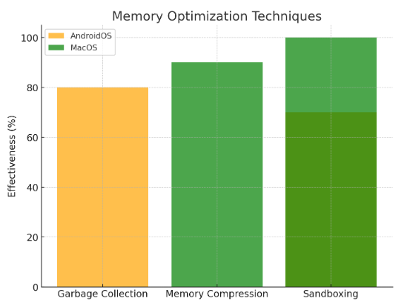

## **3. File System**

**AndroidOS:**

* Employs ext-based file systems (e.g., ext4) for internal storage, optimized for fast read/write operations [2].
* Implements scoped storage in newer versions to improve app data privacy by isolating app-specific data [2].
* Utilizes StorageManager APIs for granular file access and efficient management of shared and private storage [2].

**MacOS:**

* Uses the Apple File System (APFS), optimized for SSDs, with features like snapshots for quick backups, native encryption, and fast directory sizing [1].
* Supports a hierarchical file structure, enhancing data organization and accessibility [3].
* Provides Time Machine backups, leveraging APFS snapshots for seamless and reliable data recovery [3].

## **4. Security**

**AndroidOS:**

* Relies on SELinux for enforcing fine-grained access control policies across processes [2].
* Provides app sandboxing and permissions, ensuring apps operate in isolated environments [2].
* Uses Google Play Protect to scan for malware and enforces regular security updates [2].

**MacOS:**

* Incorporates System Integrity Protection (SIP) to prevent unauthorized modifications to system-critical files [3].
* Employs Gatekeeper to validate app legitimacy through developer signatures and XProtect for malware detection [3].
* Enhances privacy by processing sensitive user data locally, reducing exposure to external threats [3].

## **5. Scheduling**

**AndroidOS:**

* Leverages the Completely Fair Scheduler (CFS), which assigns fair CPU time slices to processes based on their weight, ensuring responsiveness [2].
* Implements priority-based scheduling for background and foreground tasks, preventing background activities from degrading the user experience by allocating minimal resources to low-priority processes [2].

**MacOS:**

* Employs preemptive scheduling to dynamically allocate CPU resources to processes, ensuring critical tasks are prioritized [1].
* Utilizes cooperative scheduling for specific system services, allowing processes to voluntarily yield CPU time for optimized multitasking [3].

## **6. Analogy**

Imagine AndroidOS and MacOS as two cities with distinct governance models:

* **AndroidOS** is like a bustling open-market city with dynamic rules. Vendors (apps) freely set up shops following general guidelines but manage their own security and interactions. The city adapts rapidly, incorporating new trends and businesses [2].
* **MacOS** resembles a gated community. Every vendor undergoes thorough vetting before entry, and strict rules ensure uniformity and security. The environment offers residents (users) a curated and consistent experience [3].

## **7. Insights and Observations**

* **Customization vs. Control:** AndroidOS provides unmatched flexibility, making it suitable for diverse hardware and applications. MacOS prioritizes stability and security by enforcing strict controls, ensuring a consistent user experience [1].
* **Security Trade-offs:** MacOS’s stringent security measures appeal to privacy-conscious users, while AndroidOS requires active user vigilance due to its open-source nature and broader attack surface (Android OS Case Study, 2019; MacOS versus Microsoft Windows, 2024).
* **Developer Ecosystems:** AndroidOS’s open-source APIs attract developers focused on innovation and customization. In contrast, MacOS appeals to developers seeking streamlined, high-performance environments with strong user trust (A Comparative Study of Operating Systems, 2020; MacOS versus Microsoft Windows, 2024).
* **Enterprise Deployment:** For businesses, MacOS offers robust security and integration within Apple’s ecosystem, making it ideal for sensitive environments. AndroidOS provides scalability and adaptability for diverse enterprise needs, including BYOD policies (Android OS Case Study, 2019; MacOS versus Microsoft Windows, 2024).

## **8. Comparative Analysis of AndroidOS and MacOS: Key Differences**

|  |  |  |
| --- | --- | --- |
| Aspect | AndroidOS | MacOS |
| Foundation | Linux-based, open-source | UNIX-based, proprietary |
| Target Devices | Mobile devices, tablets, IoT | Desktops, laptops, and Apple-exclusive hardware |
| Process Management | Hierarchical: Foreground, visible, service, background, and empty processes | Preemptive multitasking, process isolation with priority-based threading |
| Memory Management | Uses garbage collection (ART), Zygote process for memory sharing | Advanced virtual memory, memory compression, application sandboxing |
| File System | Ext4 for internal storage, scoped storage for app data privacy | APFS with features like snapshots, encryption, and fast directory sizing |
| Security | SELinux for fine-grained access control, Google Play Protect, app sandboxing | System Integrity Protection, Gatekeeper, and XProtect for malware detection |
| Scheduling | Completely Fair Scheduler (CFS), priority-based task management | Preemptive and cooperative scheduling for multitasking |
| Customization | High; supports diverse hardware and software configurations | Limited; designed for integration and uniformity within Apple’s ecosystem |
| Developer Ecosystem | Open APIs for innovation, customization, and wide hardware compatibility | Streamlined APIs for optimized performance and premium applications |
| Privacy | User-driven, dependent on app permissions and user settings | Strong local data privacy and stringent app security policies |
| Enterprise Use | Scalable, adaptable for BYOD policies | Robust security, ideal for controlled and sensitive environments |

This comparative analysis highlights the unique strengths and limitations of AndroidOS and MacOS. AndroidOS offers flexibility and compatibility, catering to a wide range of devices and use cases. MacOS, with its emphasis on security and seamless integration, excels in delivering a premium and controlled user experience. The choice ultimately depends on individual or organizational priorities, such as customization, security, or ecosystem compatibility (A Comparative Study of Operating Systems, 2020; MacOS versus Microsoft Windows, 2024).

## **References**

[1] A Comparative Study of Operating Systems: Case of Windows, UNIX, Linux, Mac, Android and iOS. (2020). International Journal of Computer Applications, 176(39). Retrieved from <https://www.researchgate.net/publication/372400705>

[2] Android OS Case Study. (2019). Retrieved from <https://www.researchgate.net/publication/350992546_Android_OS_CASE_STUDY>

[3] MacOS versus Microsoft Windows: A Study on the Cybersecurity and Privacy User Perception of Two Popular Operating Systems. (2024). Symposium on Usable Security and Privacy. Retrieved from <https://www.cemtopcuoglu.com/publications/usec2024macoswindows.pdf>